Adaptive Sleep Mask – Output explanation Report
Submitted By: Ayan Biswa Dutta & I. Dhanush
Team Number: 17

1. Introduction
The Adaptive Sleep Mask is an AI-powered sleep optimization system designed to monitor sleep stages in real-time and provide adaptive interventions to improve sleep quality. This report provides a comprehensive overview of the software architecture, explaining how each component works and how the system could be integrated with physical hardware.

2. System Architecture
The system is organized into several key components:
- Sensor Simulation - Simulates biometric sensors (PPG, eye movement, motion)
- Sleep Stage Classification - Analyzes sensor data to classify sleep stages
- Environment Control - Applies interventions based on sleep stage and disturbances
- User Scenarios - Manages different sleep scenarios and user profiles
- Dashboard - Provides visualization and control interface
- BLE Mock - Simulates Bluetooth communication with the physical device

2.1 System Flow
- Sensors collect biometric data (heart rate, eye movement, motion)
- Data is processed and fed into the sleep stage classifier
- The classifier determines the current sleep stage (Awake, Light, Deep, REM)
- Based on the sleep stage and any detected disturbances, the environment controller applies appropriate interventions
- The dashboard visualizes the data and allows user configuration
- All data is logged for later analysis

3. Component Details

3.1 Sensor Simulation (simulation/sensor_simulation.py)
The SensorSimulator class generates synthetic biometric data that mimics real sensor readings from a sleep mask.

Key Features:
- Generates realistic PPG (photoplethysmography) signals based on heart rate
- Simulates eye movement patterns specific to each sleep stage (especially REM)
- Creates motion data with occasional position changes and movements
- Produces a realistic sequence of sleep stages based on user profile characteristics

How It Works:
# Generate a full sleep session
simulator = SensorSimulator(user_profile_id="light_sleeper", session_duration_hours=8)
data = simulator.generate_full_session()
# Generate a single real-time sample
sample = simulator.generate_real_time_sample(current_stage="rem")

Integration with Physical Device:
In a physical implementation, this module would be replaced with actual sensor readings from: - PPG sensor for heart rate monitoring - IR eye movement sensor - Accelerometer/gyroscope for motion detection
The data structures and processing pipeline would remain similar, but instead of generating synthetic data, the system would read and process real sensor inputs.

3.2 Environment Control (simulation/environment_control.py)
The EnvironmentController manages interventions based on sleep stages and environmental disturbances.

Key Features:
- Applies different interventions for each sleep stage
- Adjusts interventions based on user preferences
- Responds to environmental disturbances (noise, light, movement)
- Logs all interventions for analysis

Intervention Types:
- Light Dimming - Controls mask LED brightness
- Sound Playback - Provides white noise, binaural beats, etc.
- Vibration Feedback - Gentle haptic feedback

How It Works:
# Create controller for a specific user profile
controller = EnvironmentController(user_profile_id="light_sleeper")
# Apply intervention based on sleep stage and possible disturbance
intervention = controller.apply_intervention("rem", disturbance="noise")

Integration with Physical Device:
In a physical implementation, this module would control: - LED lights embedded in the mask - Small speakers or bone conduction audio - Vibration motors for haptic feedback
The _apply_light_dimming(), _apply_sound(), and _apply_vibration() methods would be modified to send commands to the physical components instead of just printing messages.

3.3 Sleep Stage Classification (models/mock_classifier.py)
The MockSleepStageClassifier analyzes sensor data to determine the current sleep stage.

Key Features:
- Processes windows of sensor data to extract relevant features
- Uses rule-based classification to identify sleep stages
- Provides confidence scores for each possible stage
- Supports real-time classification of streaming data

Classification Rules:
Each sleep stage has characteristic patterns: - Awake: Higher heart rate, more eye movement, more motion - Light Sleep: Moderate heart rate, less eye movement, less motion - Deep Sleep: Lowest heart rate, minimal eye movement, minimal motion - REM Sleep: Moderate heart rate, rapid eye movements, low motion

How It Works:
# Create and train classifier
classifier = MockSleepStageClassifier()
classifier.train(training_data)
# Make real-time prediction on a window of sensor data
stage, probabilities = classifier.predict_real_time(sensor_window)

Integration with Physical Device:
In a production implementation: - The mock classifier would be replaced with a trained neural network model - The model could be optimized for edge computing to run on the device - Alternatively, the device could send data to a smartphone app for processing - The classification pipeline would remain similar, but with a more sophisticated model

3.4 User Scenarios (simulation/user_scenarios.py)
The UserScenario class orchestrates the simulation of different sleep scenarios.

Key Features:
- Manages the interaction between sensor simulation and environment control
- Applies scenario-specific modifications to sleep patterns
- Supports real-time or accelerated simulation
- Provides callback mechanism for UI updates

Predefined Scenarios:
- Normal Night: Typical sleep cycles
- Noisy Night: Frequent noise disturbances
- REM Enhancement: Focus on extending REM sleep
- Sleep Onset Insomnia: Difficulty falling asleep
- Frequent Awakenings: Multiple awakenings throughout the night

How It Works:
# Create a scenario
scenario = UserScenario(
user_profile_id="light_sleeper",
scenario_name="noisy_night",
duration_hours=8,
real_time=False,
time_acceleration=60
)
# Run simulation
sensor_data, intervention_data = scenario.run_simulation()

Integration with Physical Device:
In a real-world implementation: - The scenario system would be part of the companion app - It would analyze historical data to identify the user’s sleep patterns - The app would recommend specific interventions based on identified issues - The device would be configured according to the selected scenario

3.5 Dashboard (app/simple_dashboard.py)
The dashboard provides a visual interface for monitoring and controlling the sleep mask.

Key Features:
- Displays real-time sensor data and sleep stage classification
- Visualizes intervention history
- Allows configuration of user profiles and scenarios
- Provides model training and evaluation tools

Integration with Physical Device:
In a production implementation: - The dashboard would be part of a mobile app - It would connect to the physical device via Bluetooth - The app would store historical data and provide sleep analytics - Users could configure their preferences and view their sleep history

3.6 BLE Mock (app/ble_mock.py)
The BLEMock class simulates Bluetooth Low Energy communication with the device.

Key Features:
- Simulates device connection and disconnection
- Handles command queue for device control
- Provides notification system for device events
- Manages device information and battery status

How It Works:
# Create BLE interface
ble = BLEMock(user_profile_id="light_sleeper")
# Connect to device
ble.connect()
# Send command to device
ble.send_command("start_session")
# Receive notifications from device
ble.register_notification("battery", on_battery_update)

Integration with Physical Device:
In a physical implementation: - This module would be replaced with actual BLE communication - It would handle pairing, connection management, and data transfer - The command and notification structure would remain similar - Additional security features would be implemented for data protection

4. Hardware Integration

4.1 Required Hardware Components
To implement the Adaptive Sleep Mask as a physical device, the following components would be needed:
- Microcontroller - Low-power MCU (e.g., ESP32, nRF52)
- Sensors:
  - PPG sensor for heart rate monitoring
  - IR proximity sensors for eye movement detection
  - Accelerometer/gyroscope for motion detection
- Actuators:
  - Dimmable LEDs for light control
  - Small speakers or bone conduction transducers
  - Vibration motors for haptic feedback
- Communication - Bluetooth Low Energy (BLE) module
- Power - Rechargeable battery with power management
- Physical Design - Comfortable mask with embedded electronics

4.2 Software Modifications for Hardware Integration

Sensor Data Collection
Replace the SensorSimulator with a hardware interface:
class HardwareSensorInterface:
def __init__(self):
self.ppg_sensor = PPGSensor(pin=GPIO_PPG)
self.eye_sensor = IRSensor(pin=GPIO_IR)
self.motion_sensor = AccelerometerSensor(i2c_addr=ACCEL_ADDR)
def read_sensors(self):
return {
'ppg': self.ppg_sensor.read(),
'eye_movement': self.eye_sensor.read(),
'motion': self.motion_sensor.read(),
'timestamp': datetime.now()
}

Environment Control
Modify the intervention methods to control physical components:
def _apply_light_dimming(self, intensity):
# Control actual LEDs
pwm_value = int(intensity * 255)
self.led_controller.set_brightness(pwm_value)
return intensity
def _apply_sound(self, sound_type):
if sound_type is None:
self.audio_controller.stop()
return None
# Play actual sound file
sound_file = f"sounds/{sound_type}.mp3"
self.audio_controller.play(sound_file)
return sound_type
def _apply_vibration(self, intensity):
if intensity <= 0:
self.vibration_controller.stop()
return 0
# Control vibration motor
pwm_value = int(intensity * 255)
self.vibration_controller.set_intensity(pwm_value)
return intensity

BLE Communication
Replace the mock BLE with actual Bluetooth communication:
class BLEController:
def __init__(self):
self.ble = BLEPeripheral()
self.tx_characteristic = self.ble.add_characteristic(
uuid=TX_CHAR_UUID,
properties=["notify", "read"],
value=b""
)
self.rx_characteristic = self.ble.add_characteristic(
uuid=RX_CHAR_UUID,
properties=["write"],
value=b"",
on_write=self._handle_command
)
def start_advertising(self):
self.ble.start_advertising("SleepMask")
def _handle_command(self, data):
# Parse command and execute
cmd = json.loads(data.decode())
if cmd["type"] == "set_intervention":
self.environment_controller.apply_intervention(
cmd["data"]["sleep_stage"],
cmd["data"].get("disturbance")
)

4.3 Power Management
For a wearable device, power efficiency is critical:
- Sleep Modes - Put the MCU into deep sleep when not actively processing
- Sensor Duty Cycling - Sample sensors at different rates based on importance
- BLE Connection Intervals - Use longer connection intervals when possible
- Adaptive Processing - Reduce classification frequency during stable sleep stages
def power_management_loop():
while True:
# Check if user is likely asleep
if motion_stable_for_minutes(10):
# Reduce sampling rates
ppg_sensor.set_sampling_rate(0.2) # 5-second intervals
motion_sensor.set_sampling_rate(0.1) # 10-second intervals
# Increase BLE connection interval
ble.set_connection_interval(500) # 500ms
# Enter light sleep between samples
mcu.light_sleep(5000) # 5 seconds
else:
# Normal operation mode
ppg_sensor.set_sampling_rate(1.0) # 1-second intervals
motion_sensor.set_sampling_rate(0.5) # 2-second intervals
ble.set_connection_interval(100) # 100ms

5. Machine Learning Model Optimization
For deployment on a resource-constrained device, the sleep stage classification model would need optimization:

5.1 Model Compression Techniques
- Quantization - Reduce precision of model weights (e.g., from float32 to int8)
- Pruning - Remove unnecessary connections in the neural network
- Knowledge Distillation - Train a smaller “student” model to mimic a larger “teacher” model
- TensorFlow Lite or ONNX Runtime - Use optimized inference engines

5.2 Edge Computing vs. Cloud Processing
Two possible approaches:
- Edge Computing:
  - Run simplified model on the device
  - Provide real-time feedback without connectivity
  - Preserve privacy by keeping data local
  - Limited by computational resources
- Hybrid Approach:
  - Basic processing on device for immediate feedback
  - Send data to smartphone app for more complex analysis
  - Periodically sync with cloud for advanced analytics
  - Best balance of responsiveness and sophistication

6. User Experience Considerations

6.1 Companion App Design
The companion app should provide:
- Onboarding - Guide users through device setup and profile creation
- Sleep Tracking - Visualize sleep stages, quality, and trends
- Personalization - Allow customization of interventions and preferences
- Insights - Provide actionable recommendations based on sleep data
- Integration - Connect with other health and smart home systems

6.2 Feedback Mechanisms
The physical device should provide:
- Subtle Indicators - Minimal LEDs to show status without disturbing sleep
- Haptic Feedback - Gentle vibrations for notifications
- Audio Cues - Optional sounds for alerts and feedback
- Automatic Adaptation - Learn user preferences over time

7. Future Enhancements

7.1 Advanced Features
- Multi-sensor Fusion - Combine data from additional sensors (temperature, ambient light, sound)
- Smart Home Integration - Connect with smart lights, thermostats, and other devices
- Voice Control - Add voice commands for hands-free operation
- Social Features - Optional sharing and comparison with friends or family
- Health Integration - Connect with health platforms (Apple Health, Google Fit)

7.2 Research Opportunities
- Personalized Intervention Optimization - Use reinforcement learning to find optimal interventions
- Sleep Disorder Detection - Train models to identify signs of sleep disorders
- Circadian Rhythm Analysis - Study and optimize alignment with natural rhythms
- Longitudinal Studies - Analyze long-term effects of adaptive interventions

8. Conclusion
The Adaptive Sleep Mask system provides a comprehensive framework for monitoring sleep and applying real-time interventions to improve sleep quality. The simulation demonstrates the feasibility of the approach and provides a foundation for developing a physical device.
By integrating the software components with appropriate hardware, the system could be transformed into a practical wearable device that helps users optimize their sleep through personalized, adaptive interventions.
The modular architecture allows for incremental development and testing, making it possible to validate individual components before full integration. This approach reduces development risk and allows for iterative improvement based on user feedback and real-world performance.

9. GUI of the dashboard
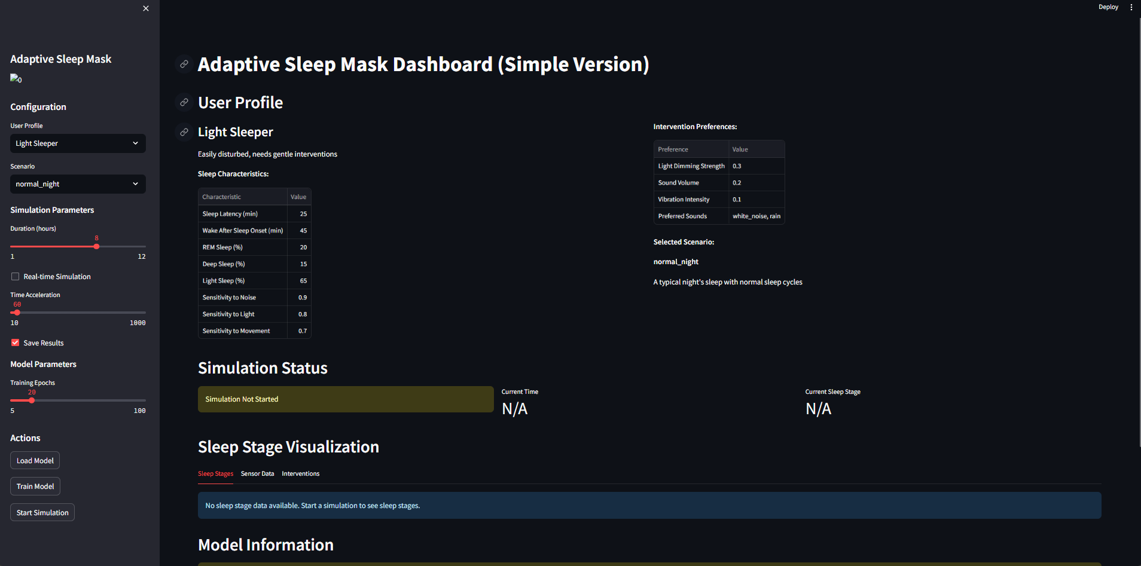
On the configuration section, the user will have option to switch between light sleeper, REM Deficient or Noisy Environment sleeper.
Further various scenarios are considered like normal night, noisy night, rem enhancement, sleep onset insomnia, frequent awakenings. The user can select these after selecting the type of user profile.
There is a basic classification model too, which can be loaded, trained and simulated in real time in the dashboard. The data is collected in real time through sensors attached. The data is processed and loaded into the model which finally gives us various characteristics as outputs.

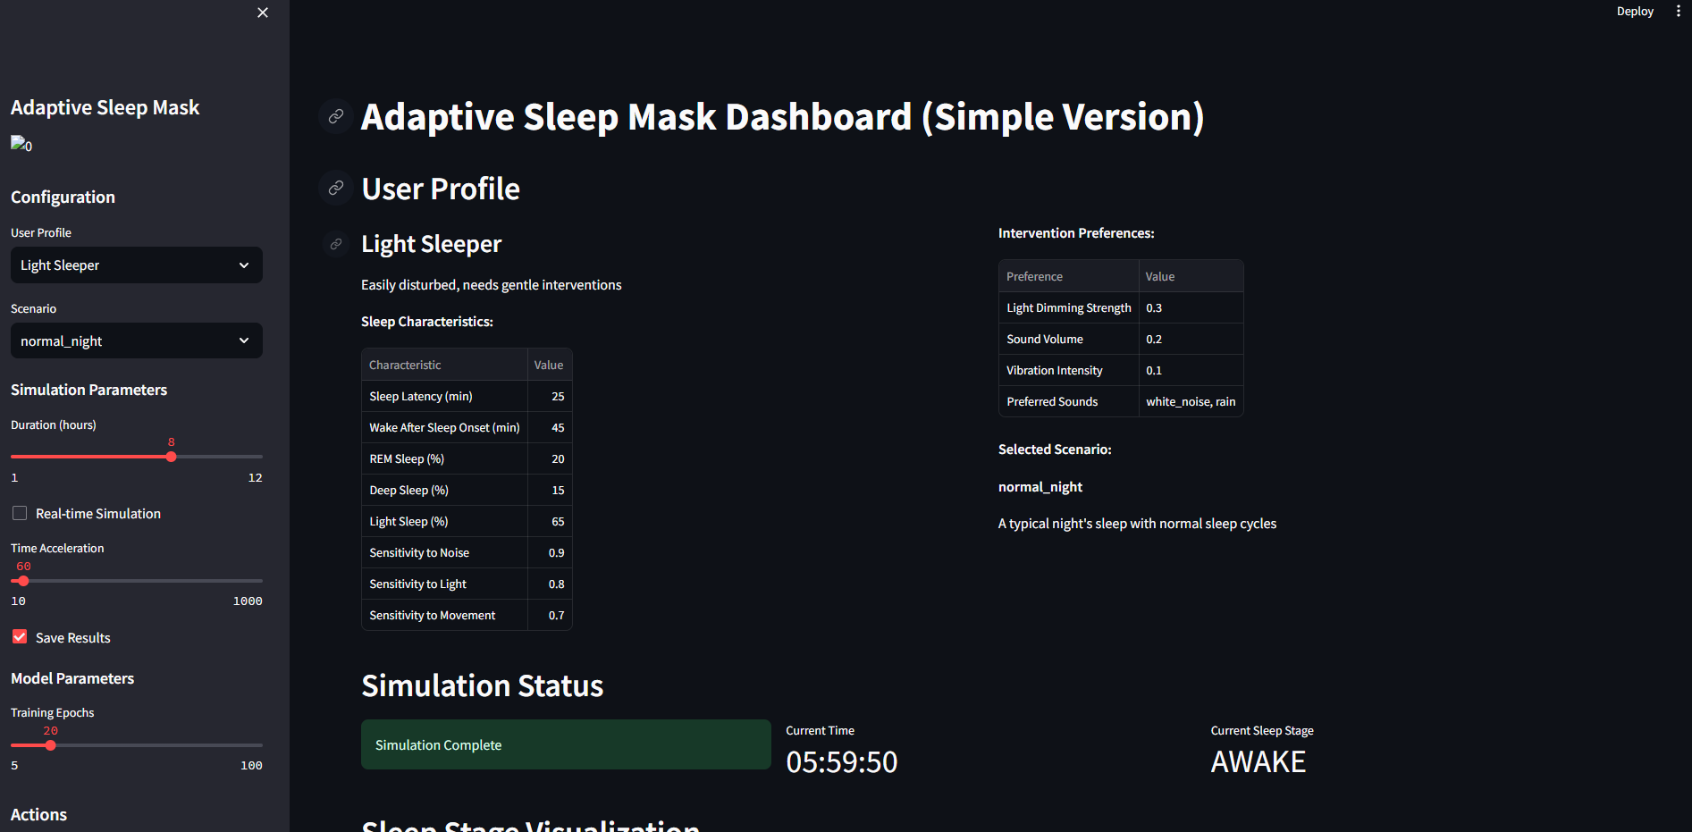
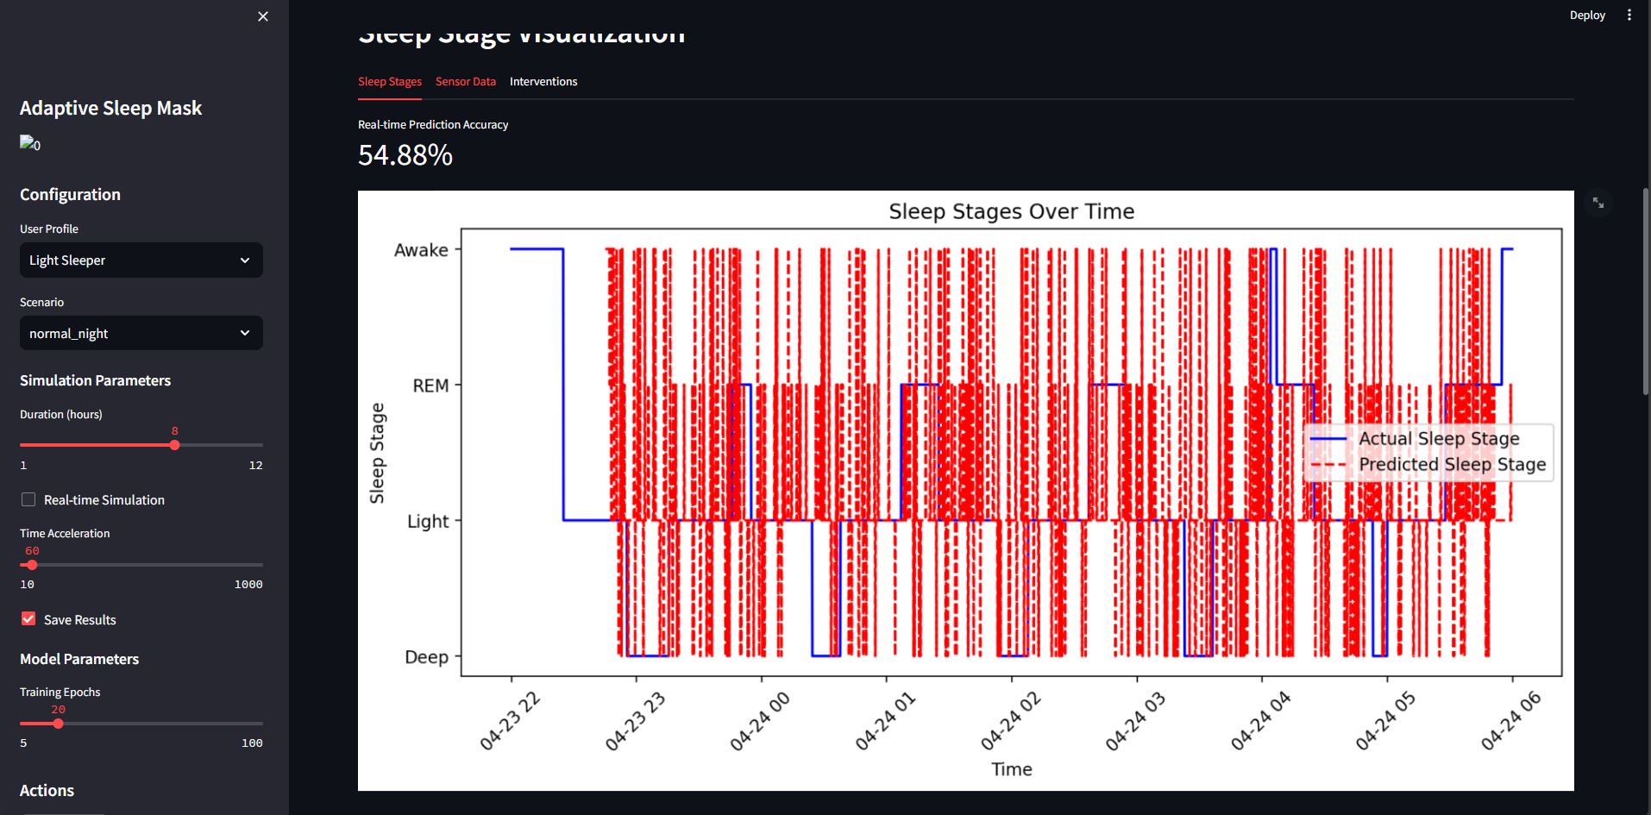
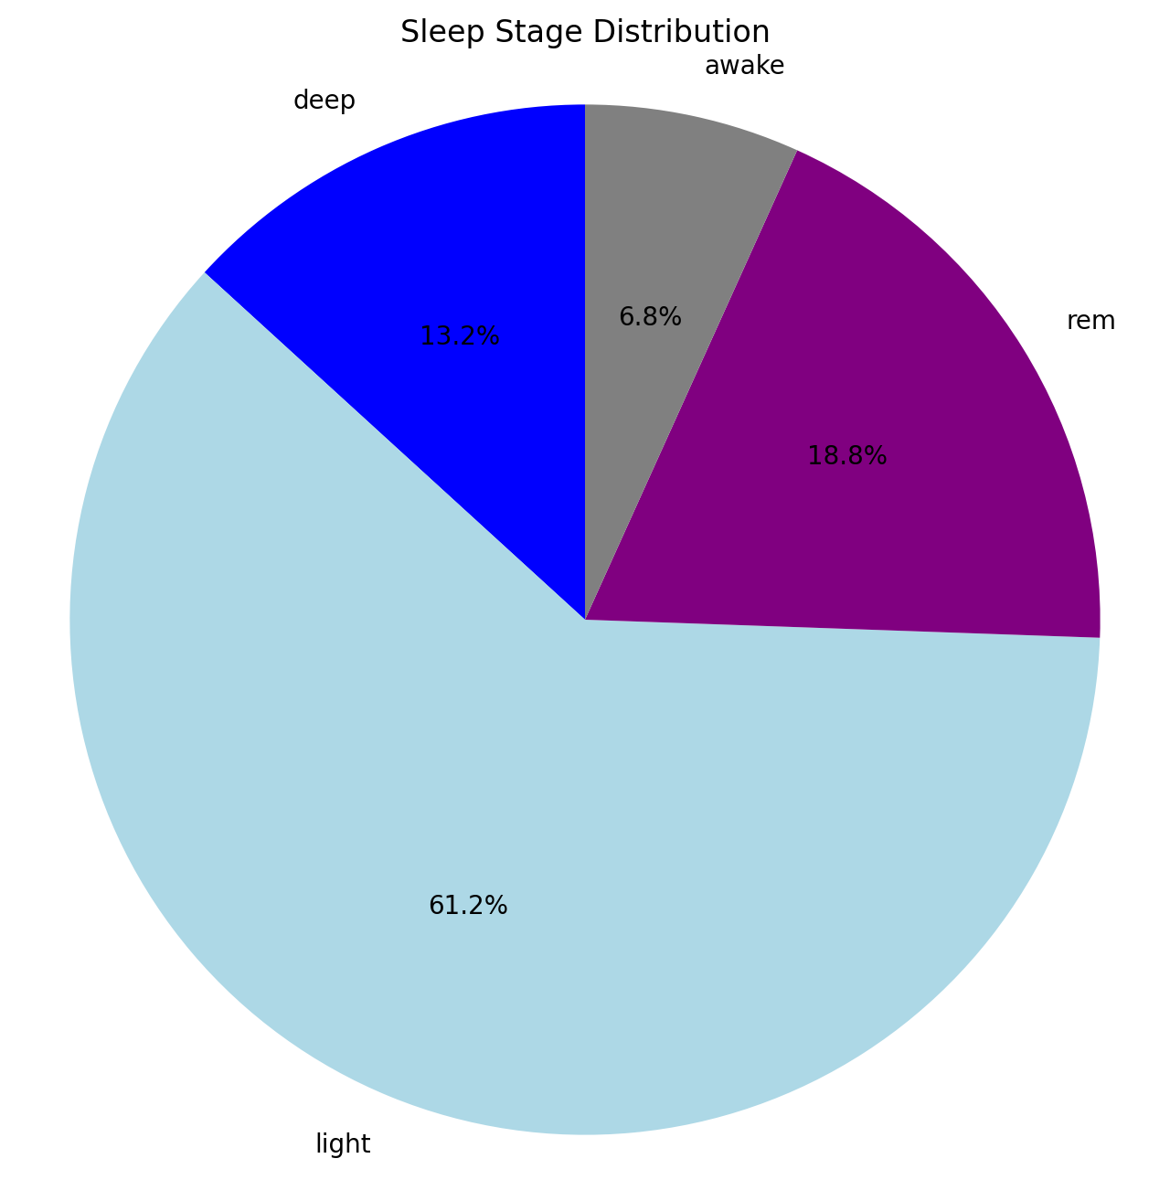

As shown it gives various sleep characteristics like Sleep latency, wake after sleep onset, REM sleep percentage etc. The simulation runs for the duration for which the subject is sleeping.
Graphs related to sleep quality and sleep stage distribution are also shown.

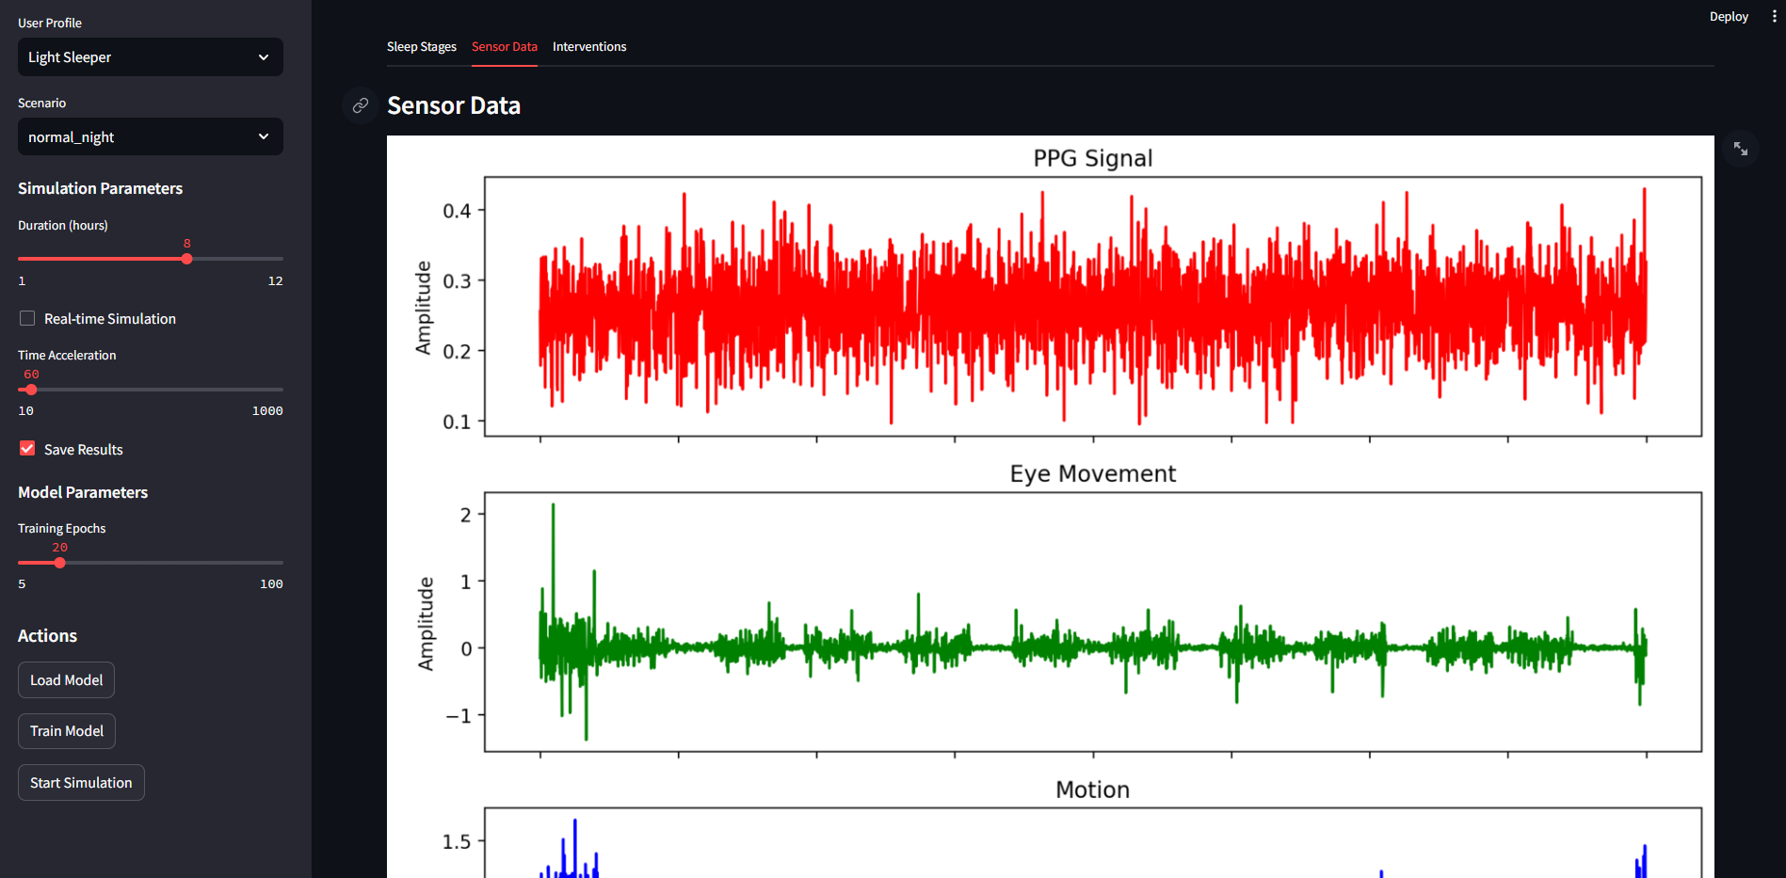
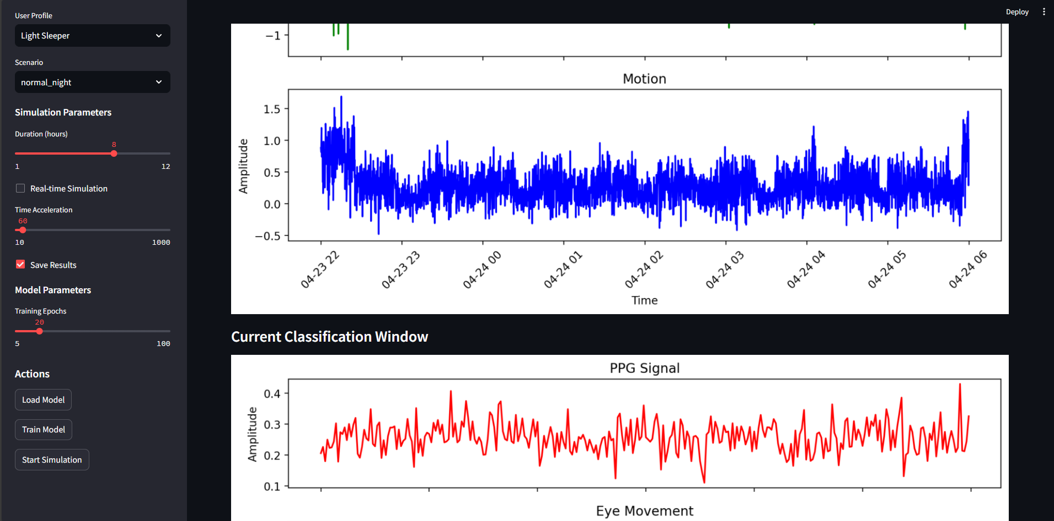
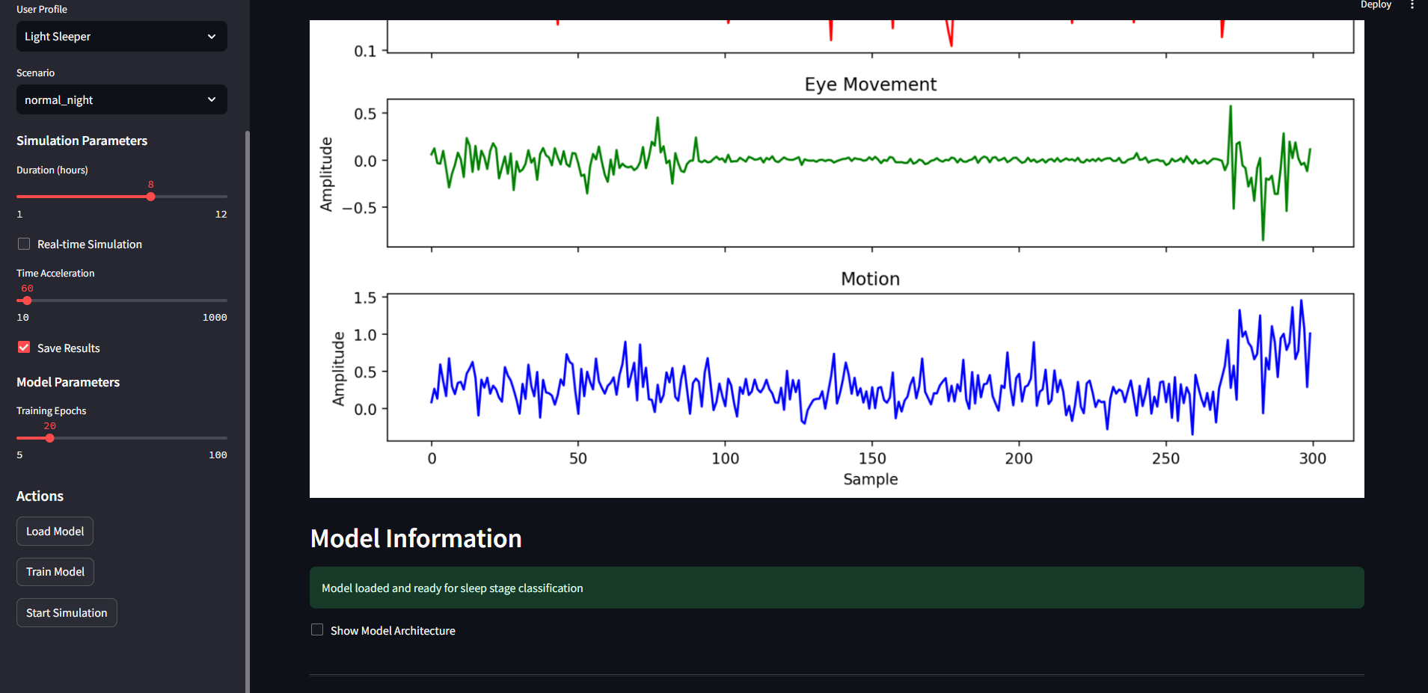

It further shows how interventions were mitigated using the features of the device whenever the subject had any during the sleep period. The graphs show how the different sleep enhancement features included in our device performed.


